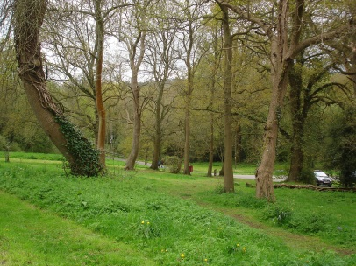
AUTUMN 2019 NEWSLETTER

Parish Councillors:
Mr I Foster Chairman 876734
Mr J Chiverton Vice Chairman 888922
Mr I Fairbrother 888071
Mr D Goldhawk 888119
Mr K Carter 07803 260834
Mr J Afford 883074
Mrs M J E Mansell 711998
Mrs J Russell Clerk to the Council 885282

Email: Holmwood.pc@gmail.com Website: www.holmwoodparishcouncil@gov.uk

District Councillors:
Ms C. Malcolmson cllr.malcomson@molevalley.gov.uk County Councillor:
Mr C. Wellman cllr.wellman@molevalley.gov.uk Mr S Cooksey
Mr W Monkman cllr.monkman@molevalley.gov.uk stephen.cooksey@surreycc.gov.uk

_______________________________________________________________________________________________

PARISH COUNCIL ELECTIONS.
The Parish Council is pleased to announce the election of two new Councillors, Keith Carter and James Afford. Ian Foster has been elected the new Chairman of the Parish Council with John Chiverton taking on the role of Vice Chair. All are warmly welcomed onto the Parish Council in their new roles.

FUTURE MOLE VALLEY - MODEST ADDITIONS TO RURAL VILLAGES
Mole Valley District Council has regretfully had to postpone publishing its draft local plan again. Information has been received from Councillor Margaret Cooksey, Cabinet Member for Planning. Due to the uncertain national political landscape, it is the intention of Mole Valley District council to postpone the Local Plan consultation, which had been scheduled to take place between 21 October and 1 December 2019. This will require formal agreement by Cabinet at a meeting on 24 September.

WAR MEMORIAL
The steps leading up to the War Memorial, will be repointed during week commencing 23 September.

PLAYGROUND
All problems identified in the annual Safety Inspection of the playground will be attended to without delay.
The safety bollards, which are to be erected outside the safety gate at the playground will be installed at the end of September.

VERGE CUTTING
The Parish Council was disappointed with the severe verge cutting along the A24 this year. The Parish Council have since been informed that discussions have taken place to allow wildflowers to grow in the verges to in future.

ESSENTIAL GAS MAIN REPAIRS TO A24 AND HOLMWOOD VILLAGE
SGN have still not started work on these essential repairs. Any further information received will be post on the Parish noticeboard.

RANMORE ROAD WASTE RECYCLING CENTRE.
There is still no final decision on the outcome of the Ranmore Road recycling centre.
When further information is received, the Parish Council will post it on the notice board.

