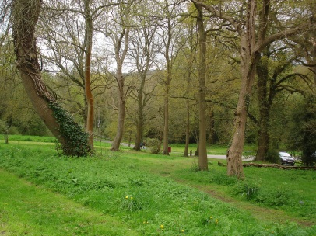
AUTUMN 2021 NEWSLETTER

Parish Councillors:
Mr K Carter Chairman 07803 260834
Mr J Chiverton Vice Chairman 888922
Mr D S C Goldhawk 888119
Mr I Fairbrother 888071
Mr J Afford 883074
Mrs M J E Mansell 711998
Mrs R Snook 888673
Mrs J Russell Clerk to the Council 885282

Email: clerk@holmwoodparishcouncil.gov.uk
Website: www.holmwoodparishcouncil@gov.uk

District Councillors:
Ms C. Malcolmson cllr.malcomson@molevalley.gov.uk County Councillor:
Mr C. Wellman cllr.wellman@molevalley.gov.uk Mr S Cooksey
Mrs R Hobbs cllr.hobbs@molevalley.gov.uk stephen.cooksey@surreycc.gov.uk

________________________________________________________________________________________________

A WARM WELCOME BACK
After such a long absence, your Council is pleased to be able to reinstate the Newsletter for the parish. Please be assured that although Covid restrictions have been relaxed nationally, the Council will make every effort to ensure the delivery of your Newsletter is undertaken ensuring everyone continues to stay safe. During lockdown, the Council held meetings via Zoom but now hold meetings in the Village Hall. As usual, these take place every two months, and a warm welcome is extended to anyone who wishes to come along. The date and the agenda for each meeting will be published on the Council noticeboard outside the Village Hall and on the website.

NEW CHAIRMAN.
The Council is pleased to announce that Councillor Keith Carter was elected the new Parish Council Chairman at the May 2021 meeting and Councillor John Chiverton has been elected as the new Vice Chairperson.

PLAYGROUND
Following the annual Safety Inspection your Council has been notified of repairs to the safety surfacing that were identified for

immediate attention. These repairs are being acted upon and will ensure the playground provides a safe environment for children to play.
During the past year, the Council has continued to increase the funds earmarked for the purchase of a new piece of playground and is keen to know what equipment would be most popular. Please do make the Council aware of what your children would prefer so that a decision can be made at the November Council meeting.
Email clerk@holmwoodparishcouncil.gov.uk.
There was a delay in installing the new litter bins purchased by the Parish Council, but this work is now completed and it is hoped the addition of a new bin will encourage everyone to dispose of litter properly.

WAR MEMORIAL
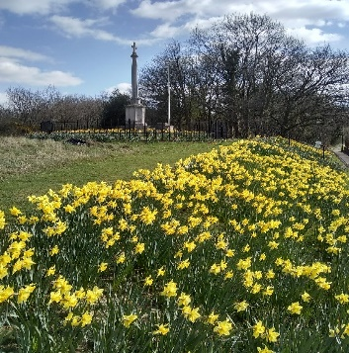
The steps leading up to the War Memorial have been repointed, reducing the risk of slips, trips and falls.

